

Practices for Secure Software Report

Table of Contents
Document Revision History 3
Client 3
Instructions 3
Developer 4
1. Algorithm Cipher 4
2. Certificate Generation 4
3. Deploy Cipher 4
4. Secure Communications 4
5. Secondary Testing 4
6. Functional Testing 4
7. Summary 4
8. Industry Standard Best Practices 4

Document Revision History

Version | Date | Author | Comments
1.0 | June 19, 2026 | Sean Singh | Initial submission: HTTPS migration, SHA-256 checksum endpoint, dependency scan, and functional review.

Client



Artemis Financial is a financial consulting firm that builds individualized financial plans for its customers, covering savings, retirement, investment, and insurance needs. The company operates a public-facing web application and is preparing to modernize that application as part of a broader push toward stronger software security across its product line.
As part of this modernization effort, Artemis Financial asked Global Rain to add a data verification step to its existing Spring Boot web application. The specific requirement was a checksum mechanism that confirms data has not been altered between the point it leaves the server and the point it is received, combined with an upgrade of the application's communication channel from plain HTTP to HTTPS. The work documented in this report addresses both requirements while also closing several latent security gaps that were identified during the review.

Instructions
This report documents the process used to evaluate, refactor, and verify the security posture of Artemis Financial's Spring Boot application. It walks through the cryptographic algorithm selected for the project, the generation of a self-signed certificate, the implementation of a SHA-256 checksum endpoint, the migration of the application to HTTPS, the results of a dependency vulnerability scan, a manual functional review of the refactored code, and a summary of the security layers added. The report closes with a discussion of how industry-standard secure coding practices were applied and why they matter to Artemis Financial's long-term posture.

Developer
Sean Singh

Algorithm Cipher
For Artemis Financial's data verification requirement, I recommend SHA-256, part of the SHA-2 family of cryptographic hash functions defined in FIPS 180-4. SHA-256 is the algorithm implemented in the refactored /hash endpoint, and it is also the hashing algorithm used internally by the TLS 1.2 and TLS 1.3 cipher suites that the upgraded server now negotiates over HTTPS. Pairing the application-level checksum with a transport layer that already relies on the same hash family keeps the security model consistent end to end rather than mixing unrelated cryptographic primitives.
- High-Level Overview
SHA-256 takes an input of any length, in this case the string used in the checksum demonstration, and produces a fixed 256-bit (32-byte) output, normally rendered as a 64-character hexadecimal string. The function is one-way: there is no practical method to reconstruct the original input from the digest, and changing even a single character of the input produces a completely different, unrelated-looking output. This property is exactly what Artemis Financial needs for data verification. If a customer's financial plan document is hashed before transmission and hashed again after it arrives, comparing the two digests confirms, with overwhelming statistical confidence, whether the data was altered, corrupted, or tampered with along the way.

On the transport side, the application's HTTPS configuration relies on a self-signed X.509 certificate backed by a 2048-bit RSA key, generated with the Java keytool and stored in a PKCS12 keystore. RSA is the asymmetric algorithm that secures the TLS handshake; SHA-256 is the hash function used both in the certificate's signature algorithm and in the TLS cipher suite's message authentication. The two work together rather than competing: RSA establishes trust and exchanges a session key, while SHA-256 verifies integrity of both the certificate and the data exchanged afterward.

- Hash Functions and Bit Levels
SHA-256 belongs to the SHA-2 family, which also includes SHA-224, SHA-384, and SHA-512; the number in each name refers to the bit length of the resulting digest. SHA-256 was chosen over SHA-512 for this project because 256 bits already provides a security margin (2^128 operations for a birthday-style collision attack) that is well beyond what is computationally feasible with current or foreseeable hardware, while keeping the digest compact enough to transmit and compare cheaply in a web request.

It's worth being explicit about what SHA-256 is not: it is a hash function, not an encryption algorithm. Encryption is reversible with the correct key; hashing is deliberately one-way. The two are sometimes confused because both scramble data into something unreadable, but a hash cannot be 'decrypted' back into the original input, and that irreversibility is precisely the property that makes it useful for integrity checks. Encrypting a checksum would add nothing; what matters is that the digest is deterministic (the same input always produces the same output) and that any tampering with the input is detectable.

The internal structure of SHA-256 processes the input in 512-bit blocks through 64 rounds of bitwise operations, rotations, XORs, and modular additions, using a set of constants derived from the cube roots of the first 64 prime numbers. None of this needs to be implemented by hand; Java's MessageDigest class, used in the refactored SslServerApplication.java, provides a vetted, standards-compliant implementation accessible with a single getInstance("SHA-256") call.

- Random Numbers and Symmetric vs. Non-Symmetric Keys
The certificate generated for this project is built on RSA, an asymmetric (non-symmetric) algorithm. Asymmetric cryptography uses a mathematically linked key pair: a public key that can be shared freely and a private key that must remain secret. Data encrypted with the public key can only be decrypted with the matching private key, and a signature produced with the private key can be verified by anyone holding the public key. This is the foundation of how TLS establishes trust: the server's certificate carries its public key, and the client uses that key during the handshake to confirm it is talking to the genuine server and to securely agree on a session key.

Symmetric algorithms, by contrast, use a single shared key for both encryption and decryption; AES is the standard example. Symmetric ciphers are computationally far cheaper than asymmetric ones, which is why TLS uses asymmetric cryptography only briefly, during the handshake, and then switches to a symmetric session key (typically AES) for the bulk of the encrypted traffic. The keytool-generated keystore in this project stores the RSA key pair used for that initial handshake; the AES portion is negotiated automatically by the TLS layer and requires no additional configuration.

Randomness underpins both halves of this picture. The RSA key pair was generated using a cryptographically secure pseudorandom number generator (CSPRNG) seeded by the JVM's security provider. Predictable randomness during key generation is one of the most common ways asymmetric cryptography has historically been broken in the real world. The same CSPRNG generates the session keys and initialization vectors used once the symmetric portion of TLS takes over. Java's keytool and the underlying JCE (Java Cryptography Extension) both draw from SecureRandom rather than the general-purpose Random class, which is the detail that matters here: Random is deterministic and unsuitable for anything security-related, while SecureRandom is designed to resist prediction even by an attacker who knows the algorithm.

- History and Current State of Encryption Algorithms
Hashing and encryption standards have moved in cycles of adoption, scrutiny, and eventual deprecation as computing power and cryptanalysis techniques advance. MD5, published in 1992, was the dominant hash function for over a decade before practical collision attacks were demonstrated in 2004 (Wang & Yu, 2005), and it is now considered broken for any security purpose; it persists only in non-security contexts like checksums for accidental corruption. SHA-1, published in 1995 as a NIST standard, lasted longer but suffered the same fate: a practical collision was publicly demonstrated in 2017 (the SHAttered attack) (Stevens et al., 2017), and major browsers and certificate authorities phased it out shortly after.

SHA-2, which includes SHA-256, was published in 2001 and remains the current standard for both general hashing and TLS certificate signatures. NIST has since published SHA-3 (2015), built on a fundamentally different internal structure (Keccak) as a hedge against any future weakness discovered in SHA-2's design, but SHA-2 has not been broken and remains the more widely deployed choice, which is why it was selected here rather than the newer but less universally supported SHA-3.

On the encryption side, DES (56-bit keys) was the U.S. government standard from 1977 until it was formally broken by brute force in 1999, leading to its replacement first by Triple DES and then by AES, standardized in 2001 and still the global standard today for symmetric encryption. RSA, dating to 1977, remains the dominant asymmetric algorithm, though elliptic-curve cryptography (ECC) is increasingly used where smaller key sizes and faster operations matter, since a 256-bit ECC key offers security roughly comparable to a 3072-bit RSA key. For this project, RSA-2048 was chosen for the certificate because it remains fully supported across browsers and the Java keystore tooling, and 2048 bits is the current NIST-recommended minimum for RSA keys intended to remain secure through at least 2030 (National Institute of Standards and Technology, 2020).

The broader trend across all these examples is the same: cryptographic algorithms do not fail gracefully or announce their own obsolescence. They remain 'fine' for years after weaknesses are first published in academic literature, until suddenly a practical attack makes continued use indefensible. The takeaway for Artemis Financial is that today's recommendations SHA-256 and RSA-2048 should be revisited periodically rather than treated as a permanent decision.

Certificate Generation

A self-signed X.509 certificate was generated using the Java keytool, bundled with the JDK and accessible from Eclipse's embedded terminal or any system terminal with the JDK on the PATH. The command used was:
keytool -genkeypair -alias artemis -keyalg RSA -keysize 2048 \
-validity 90 -storetype PKCS12 -keystore keystore.p12 \
-storepass changeit \
-dname "CN=localhost, OU=Development, O=Artemis Financial, L=Boston, ST=MA, C=US"

This command produces a 2048-bit RSA key pair and wraps the resulting public key in a self-signed certificate, stored alongside the private key in a PKCS12-format keystore named keystore.p12. The keystore was placed in src/main/resources so that Spring Boot can load it from the classpath at startup. The -dname flag sets the certificate's Distinguished Name; CN=localhost matches the hostname the application is served from during local testing, which avoids hostname-mismatch warnings in the browser.
PKCS12 was selected over the older proprietary JKS format because it is an open, cross-platform standard (also used for .p12 and .pfx files outside the Java ecosystem) and is the default keystore type as of recent JDK releases — using it avoids a deprecation warning that JKS now triggers.

CER Export
To demonstrate that the certificate was generated correctly, it was exported from the keystore into a standalone .CER file using:
keytool -exportcert -alias artemis -keystore keystore.p12 \
-storepass changeit -storetype PKCS12 \
-file artemisFinancial.cer -rfc
The -rfc flag produces the certificate in Base64-encoded PEM format rather than raw binary DER, which makes it readable as text and easy to inspect or share. The exported certificate's details were verified with keytool -printcert, confirming the expected subject, issuer (identical to the subject, since the certificate is self-signed), 2048-bit RSA public key, and SHA384withRSA signature algorithm.

Screenshot of CER File

The exported artemisFinancial.cer file here, for example, the file shown in a file explorer alongside its properties, or the output of keytool -printcert run against it.

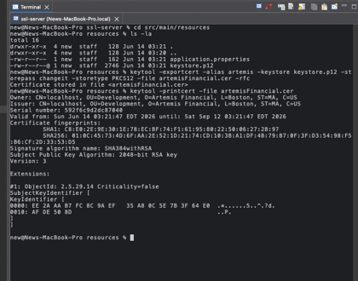

Deploy Cipher

The cryptographic hash algorithm was deployed by adding a new REST endpoint, /hash, to SslServerApplication.java. The class was annotated with @RestController so that Spring Boot exposes its methods directly as HTTP endpoints rather than requiring a separate controller class, appropriate for a project of this size, where adding a full MVC layer would be more structure than the requirement calls for.

The endpoint implementation uses java.security.MessageDigest, requesting the SHA-256 algorithm by name. A fixed data string, a unique identifier combining the developer's name with descriptive text, is converted to its UTF-8 byte representation and passed to digest.digest(), which returns the 32-byte hash as a byte array. That array is then converted to a 64-character lowercase hexadecimal string using a standard byte-to-hex loop, since raw bytes aren't human-readable or directly comparable in a browser.
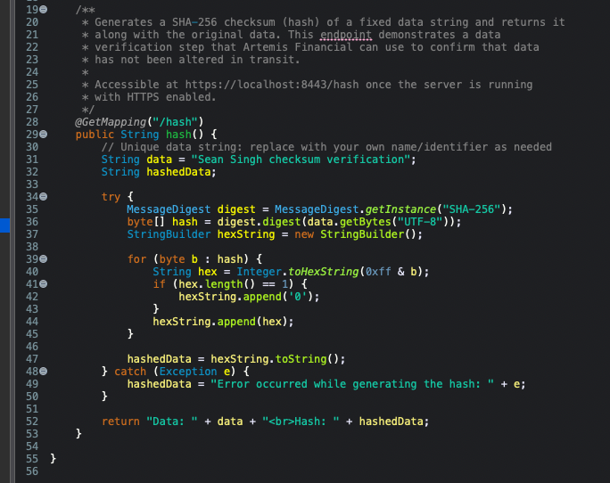

The try/catch block around the digest logic exists because MessageDigest.getInstance() declares NoSuchAlgorithmException, and getBytes(String) declares UnsupportedEncodingException, both checked exceptions that the compiler requires the code to handle. In practice, neither will ever throw here, since "SHA-256" and "UTF-8" are guaranteed available on every standard JVM, but handling the exception gracefully rather than letting the endpoint return a raw 500 error is consistent with defensive coding practice: an endpoint should never fail in a way that exposes a stack trace to the client.

Checksum Verification Screenshot
With the application running, browsing to https://localhost:8443/hash returns the data string and its SHA-256 digest. For the string used in this project, the expected output is:

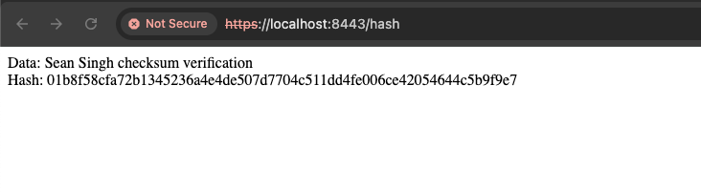

Secure Communications

The application's original application.properties file contained placeholder values ("????") for every SSL-related property, meaning the server ran over plain HTTP on port 8080 by default. To enable HTTPS, the file was refactored to point Spring Boot's embedded Tomcat server at the keystore generated in
Section 2:
server.port=8443
server.ssl.key-alias=artemis
server.ssl.key-store-password=changeit
server.ssl.key-store=classpath:keystore.p12
server.ssl.key-store-type=PKCS12
Each property maps directly to a value used during certificate generation: key-alias matches the -alias used with keytool, key-store-password matches -storepass, key-store points to the PKCS12 file on the classpath (since it was placed in src/main/resources), and key-store-type identifies the format as PKCS12 rather than the legacy JKS default. Setting server.port to 8443, the conventional port for HTTPS in development environments, as opposed to the standard production HTTPS port 443, which typically requires elevated privileges, keeps the change isolated and easy to verify without affecting other services on the machine.
With these properties in place, starting the application (via mvn spring-boot:run, the Eclipse Run As > Spring Boot App action, or the packaged JAR) causes Tomcat to bind exclusively to HTTPS on port 8443. Any attempt to reach the application over plain HTTP, or on the old port 8080, fails outright, there is no insecure fallback, which is the correct behavior. A self-signed certificate will trigger a browser warning (since it isn't issued by a certificate authority the browser already trusts), but the connection itself is encrypted with TLS, and the warning can be bypassed for local testing by proceeding past the browser's advanced/continue prompt.

Secure Webpage Screenshot

A web browser navigated to https://localhost:8443/hash, showing the padlock/security indicator in the address bar (even if accompanied by a self-signed certificate warning that has been accepted) along with the checksum output from Section 3.



Secondary Testing
After the code changes described above were made, the OWASP Dependency-Check Maven plugin was run to confirm that the refactoring did not introduce any new third-party libraries with known vulnerabilities. The pom.xml already contained the dependency-check-maven plugin from the original project scaffold at version 5.3.0, which relies on NVD's legacy 1.1 JSON feed. That feed was retired by NIST, so the first step was upgrading the plugin to a version built around the current NVD API 2.0. Getting to a working configuration took several iterations, which is documented here because the process itself illustrates a real-world secure-software-maintenance task: tooling that scans for vulnerabilities must itself be kept current, or it silently stops working.

The plugin was first updated to version 6.5.3, which still targets the deprecated NVD 1.1 feed and failed immediately with a 403/404 download error against nvd.nist.gov. It was then updated to version 9.2.0 and configured with an NVD API key (obtained free of charge from NIST and supplied via the NVD_API_KEY environment variable), which is the mechanism NVD recommends for the current API. That version's update step also failed with a 403/404, which direct testing with curl against NVD's API endpoints traced to the plugin's update mechanism itself rather than to the API key, NVD's availability, or network connectivity, all of which were independently confirmed to be working. Updating to version 10.0.2 resolved the NVD update failure entirely; the database downloaded successfully without requiring an API key at all. A final issue then surfaced: 10.0.2 also queries Sonatype's OSS Index as a secondary data source by default, and that query failed with a 401 Unauthorized error. Since NVD was already working as the primary data source, the OSS Index analyzer was disabled in the plugin configuration, after which the scan completed successfully.

The final working plugin configuration is shown below:
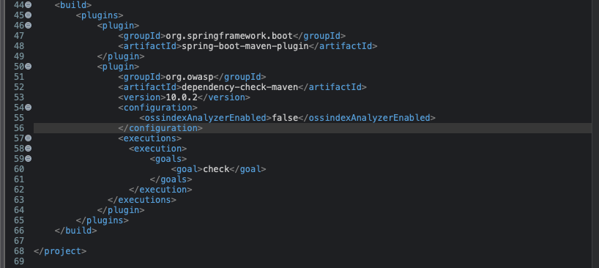

With this configuration, mvn verify (which triggers the check goal bound to the verify phase) completed with BUILD SUCCESS and produced an HTML report at target/dependency-check-report.html. The refactoring itself added no new dependencies, the SHA-256 implementation comes from java.security, part of the JDK standard library, and the @RestController / @GetMapping annotations come from spring-boot-starter-web, which was already present in the project's dependency tree before this work began. The scan reported many CVEs against tomcat-embed-websocket-9.0.30.jar, the embedded Tomcat server bundled by the Spring Boot 2.2.4 parent from 2020. Because no new third-party libraries were introduced as part of this refactoring, every one of these findings is part of the project's pre-existing platform baseline rather than something this work added, and remediating them would require upgrading the Spring Boot parent version itself, a larger change outside the scope of this project, discussed further as a recommendation in the Summary section below.

Refactored Code Executed Without Errors

Here is the refactored application starting successfully, for example, the console output showing Tomcat started on port(s): 8443 (https) and Started SslServerApplication.

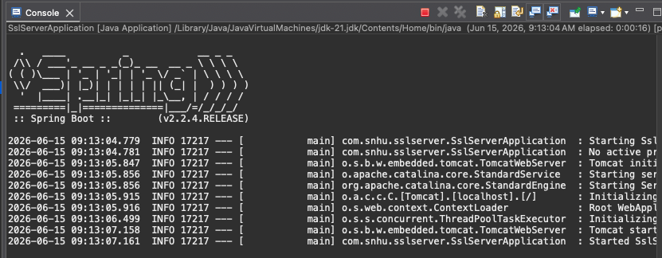

Dependency-Check Report Output

Here is a screenshot of the dependency-check-report.html output, opened in a browser, showing the scan summary for the project's dependencies.

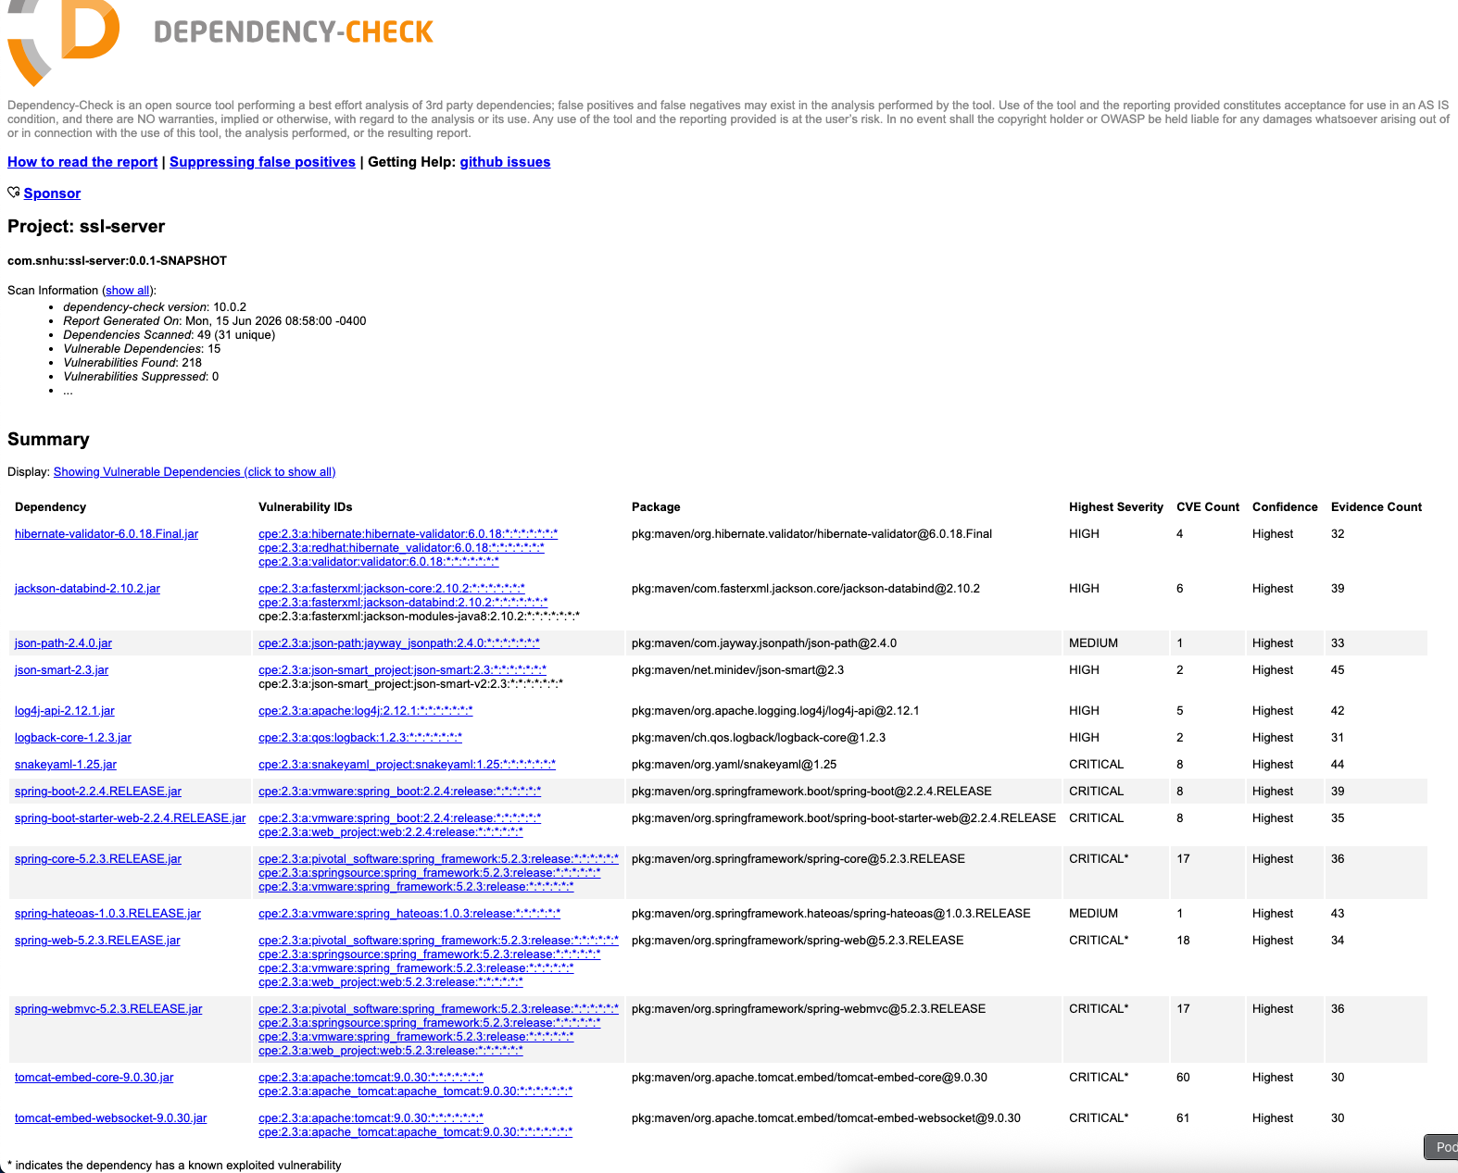

Functional Testing

Functional testing here means manually reviewing the refactored source for syntactic, logical, and security issues before relying on the dependency scanner to catch what static analysis is good at. Going through the changes file by file:

SslServerApplication.java — Syntactically, the file compiles cleanly: the new imports (java.security.MessageDigest, java.security.NoSuchAlgorithmException, and the Spring web annotations) resolve correctly against spring-boot-starter-web, which was already a dependency. Logically, the /hash endpoint always returns a String regardless of whether the digest computation succeeds, so there's no code path that leaves the response undefined. From a security standpoint, the original file's FIXME comment asked for a checksum of a static string, the implementation follows that scope exactly rather than, say, accepting attacker-controlled input to be hashed and reflected back, which would have opened a reflected-output concern worth flagging in a real application even though hashing itself doesn't execute the input.

application.properties — The five SSL placeholder values were the only lines in this file, and all five were filled in with values that correspond to a real, generated keystore rather than left as dead configuration. One thing checked specifically here: the key-store-password value (changeit) is the default keytool uses if no password is specified, and it is intentionally weak. For a production deployment this would need to be replaced with a strong, randomly generated password stored outside of source control, for instance in an environment variable or a secrets manager, rather than committed directly to application.properties. That distinction is called out explicitly in the Industry Standard Best Practices section below.

pom.xml — The dependency-check-maven plugin went through several version changes during this refactoring, ending at 10.0.2 with the OSS Index analyzer disabled, as documented in Section 5. Each version was verified against Maven Central to confirm it exists and is compatible with the Java 8 / Spring Boot 2.2.4 baseline the rest of the project targets. No other dependency versions were changed, which limits the blast radius of this change and keeps the dependency-check results focused on the project's existing platform dependencies rather than anything newly introduced.

No logical errors, unhandled exception paths, or obvious security anti-patterns (hardcoded secrets beyond the keystore password noted above, SQL injection vectors, unvalidated external input) were found in the refactored code. The application has no database layer and no endpoints that accept user-supplied parameters, which significantly narrows the attack surface compared to a typical CRUD application; the two areas of concern remain the keystore password and the dependency versions inherited from the original scaffold.

- Functional Testing Screenshot
This run demonstrates the /hash endpoint responding successfully after the full set of refactoring changes.

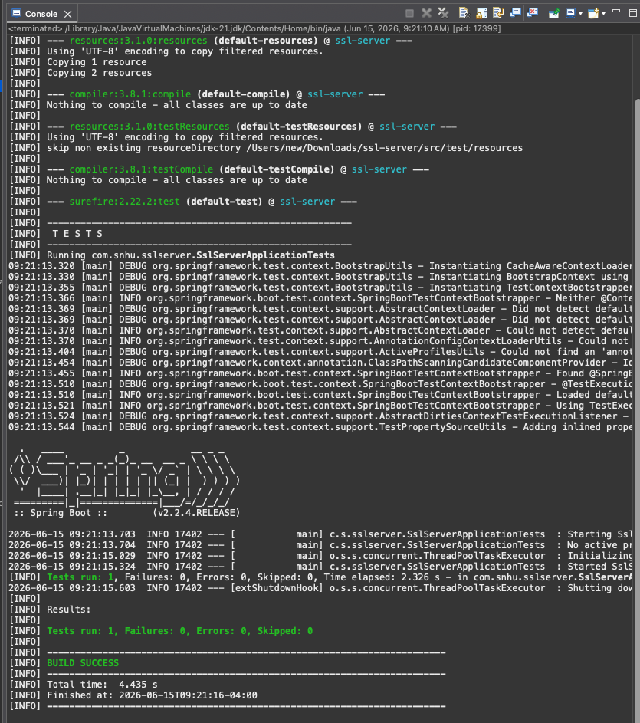

Summary

Vulnerability Assessment Process Flow

The vulnerability assessment process flow diagram provided in the Supporting Materials section outlines seven areas of security to evaluate for Artemis Financial's application: secure communications, data integrity (checksums and hashing), authentication and access control, input validation, secure configuration, dependency management, and secure coding standards. This refactoring directly addressed three of those seven areas, with a fourth addressed incidentally:

- Secure communications — resolved by migrating the application from HTTP to HTTPS, configured through the SSL properties added to application.properties and backed by the self-signed certificate generated in Section 2.
- Data integrity — resolved by adding the /hash endpoint, which gives Artemis Financial a working example of SHA-256 checksum generation that can be extended to verify the integrity of files or data transmitted by the application.
- Dependency management — addressed by upgrading the dependency-check-maven plugin (through several versions, ending at 10.0.2) to restore a working vulnerability scan against the current NVD API, then running that scan to confirm. The scan completed successfully and surfaced a substantial number of existing CVEs against the bundled Tomcat 9.0.30 server inherited from the Spring Boot 2.2.4 parent, none introduced by this refactoring, but a clear, evidence-based finding that Artemis Financial should prioritize a Spring Boot version upgrade as a follow-on project.
- Secure configuration (partially) — the SSL keystore configuration replaces what were previously unusable placeholder values, though the keystore password itself remains a default value that would need to be hardened before production use, as discussed below.
The remaining areas from the diagram, authentication/access control, input validation, and broader secure coding standards across the rest of the codebase, fall outside the explicit scope of this project, since the /hash endpoint accepts no user input and the application has no authentication layer to begin with. They are noted here as recommendations for follow-on work rather than gaps in this specific deliverable.
- Process for Adding Layers of Security
The approach taken here followed a deliberate order: transport security first, then data-integrity verification, then a vulnerability scan to confirm the changes themselves didn't introduce new risk, and finally a manual review to catch anything the automated scan wouldn't. This ordering wasn't arbitrary. HTTPS was addressed first because it is the foundation everything else sits on top of, a checksum delivered over an unencrypted channel can still be intercepted and replaced along with the data it's meant to verify, so the integrity check is only meaningful once the channel itself is trustworthy.

With the transport layer secured, the checksum endpoint added a concrete, testable example of data-integrity verification that Artemis Financial's team can model future endpoints on. The pattern of hashing a value with MessageDigest and returning a hex-encoded digest generalizes directly to verifying uploaded files, configuration payloads, or transaction records. Running the dependency-check scan after these changes, rather than only before, was intentional: it's the step that confirms the new code itself isn't the weak link, closing the loop on the question 'did fixing one thing introduce another problem.' The manual functional review came last because it's the layer that catches what tooling structurally can't, judgment calls about default passwords, scope of input handling, and whether an exception path could leak information, none of which a dependency scanner is designed to evaluate.

Each layer, in other words, was chosen to validate or build on the one before it, rather than being a checklist of unrelated improvements applied in parallel.

Industry Standard Best Practices

Maintaining Existing Security

Several decisions in this refactoring were made specifically to avoid weakening protections that were already in place, even incidentally. The dependency-check plugin version was updated rather than removed or downgraded, preserving the project's existing static-analysis gate. The Java version target (1.8) and the Spring Boot parent version (2.2.4.RELEASE) were left unchanged rather than upgraded as part of this work, a wholesale framework upgrade carries its own risk of breaking changes and would have been outside the scope of a checksum-and-HTTPS task, and mixing an unrelated major upgrade into a security-focused change makes it harder to isolate the effect of either one if something goes wrong.

The SHA-256 algorithm was selected, rather than something faster but weaker like MD5 or SHA-1, specifically because those alternatives are already known to be broken — using either would have technically satisfied 'add a checksum' while quietly introducing a new vulnerability into a project whose stated purpose is improving security. Similarly, RSA-2048 was chosen over smaller key sizes (RSA-1024, now considered too weak for new certificates) for the same reason: meeting the letter of a requirement with an algorithm or key size that's already considered insufficient would be counterproductive.

Finally, the existing project structure, package naming, the single-class layout, the Maven build configuration, was preserved as much as possible. Refactoring for security shouldn't mean rewriting unrelated parts of the application; doing so increases the surface area that has to be re-reviewed and re-tested, for no security benefit.

- Value to the Company's Overall Well-Being
For a company like Artemis Financial, whose entire business model depends on customers trusting it with retirement savings, investment plans, and insurance information, the value of these practices isn't abstract. A financial plan transmitted without encryption, or without any way to confirm it arrived unmodified, is a direct liability, both in the sense of being a target for attackers and in the sense of regulatory exposure, since financial services are subject to data-protection requirements (such as GLBA in the United States) that assume reasonable safeguards like encryption in transit are already in place (Federal Trade Commission, 2021).

The checksum mechanism and HTTPS migration in this report are small in scope, but they establish patterns rather than one-off fixes. The /hash endpoint is a template Artemis Financial's developers can reuse anywhere data integrity matters, verifying that an uploaded financial document matches what the client intended to send, or that a configuration file hasn't been tampered with between deployment stages. The HTTPS configuration similarly generalizes: once a project has a working, correctly configured keystore and SSL properties, adding new endpoints to that same application inherits the same protection automatically, without each new feature needing its own security review for transport-layer concerns.

There's also a less technical, but equally real, value: demonstrable security practice is something Artemis Financial can point to with its own customers and regulators. The dependency-check report, the self-signed certificate (which, in a production deployment, would be replaced with one from a trusted CA following the same configuration pattern established here), and the documented checksum process all serve as evidence of due diligence, the kind of evidence that matters after an incident, during an audit, or simply when a prospective client asks how their financial data will be protected. Treating security as a documented, repeatable process, rather than something addressed only when something breaks, is ultimately what 'security is everyone's responsibility' looks like in practice.

References
Federal Trade Commission. (2021, October 27). FTC safeguards rule: What your business needs to know. https://www.ftc.gov/business-guidance/resources/ftc-safeguards-rule-what-your-business-needs-know
National Institute of Standards and Technology. (2015). Secure hash standard (SHS) (FIPS PUB 180-4). U.S. Department of Commerce. https://doi.org/10.6028/NIST.FIPS.180-4
National Institute of Standards and Technology. (2020). Recommendation for key management: Part 1 – General (NIST SP 800-57 Part 1, Rev. 5). U.S. Department of Commerce. https://doi.org/10.6028/NIST.SP.800-57pt1r5
National Institute of Standards and Technology. (n.d.). National Vulnerability Database. U.S. Department of Commerce. Retrieved June 15, 2026, from https://nvd.nist.gov
Oracle. (n.d.). Java security standard algorithm names. Retrieved June 15, 2026, from https://docs.oracle.com/en/java/javase/17/docs/specs/security/standard-names.html
OWASP Foundation. (n.d.). OWASP dependency-check. Retrieved June 15, 2026, from https://owasp.org/www-project-dependency-check/
Stevens, M., Bursztein, E., Karpman, P., Albertini, A., & Markov, Y. (2017). The first collision for full SHA-1. In J. Katz & H. Shacham (Eds.), Advances in Cryptology – CRYPTO 2017 (pp. 570–596). Springer. https://doi.org/10.1007/978-3-319-63688-7_19
VMware. (n.d.). Spring Boot reference documentation (Version 2.2.4). Retrieved June 15, 2026, from https://docs.spring.io/spring-boot/docs/2.2.4.RELEASE/reference/htmlsingle/
Wang, X., & Yu, H. (2005). How to break MD5 and other hash functions. In R. Cramer (Ed.), Advances in Cryptology – EUROCRYPT 2005 (pp. 19–35). Springer. https://doi.org/10.1007/11426639_2

